

ONDOKUZ MAYIS UNIVERSITY
FACULTY OF MEDICINE INTERN DOCTORS DIRECTIVE

FIRST PART
Purpose, Scope, Basis and Definitions
Aim
ARTICLE 1 - (1) This Directive; has been prepared in order to ensure that the goals and strategies of the Faculty are carried out in harmony with the 6th grade education curriculum of Ondokuz Mayıs University Faculty of Medicine, and to determine the rights and obligations of 6th grade students.
Scope
ARTICLE 2 - (1) This Directive; covers the form of training, job descriptions, powers and responsibilities of intern doctors.
Rest
ARTICLE 3 - (1) This Directive applies to Ondokuz Mayıs University Associate and Undergraduate Education -
It has been prepared on the basis of the Teaching Regulation and the Faculty of Medicine, Medical Doctor Program Education-Training and Examination Directive.
Definitions
ARTICLE 4 - (1) In this Directive;
a) Sixth Grade Board: The board of the Faculty of Medicine responsible for executing the 6th grade education,
- Sixth Grade Coordinator: As the 6th Grade Board Coordinator, the faculty assigned by the Dean in accordance with the Education and Examination Directive of the Faculty of Medicine, and responsible for the sixth grade education and training.

- Assistant of Sixth Grade Coordinator: The faculty member who is selected from among the members of the Board by the 6th Grade Board Coordinator and who assists the Board Coordinator in the planning and coordination of the regular conduct of education and training in the 6th grade,
d)Faculty Board: Board of Ondokuz Mayıs University Faculty of Medicine,
e)Feedback Form: The questionnaire form, Required to be filled by intern doctors at the end of each internship, in which the positive aspects of the internship and the aspects that need improvement are conveyed,
f)Intern Doctor:students in the sixth grade who have been documented that they completed the first five years at Ondokuz Mayıs University Faculty of Medicine,
g)Intern Doctor Evaluation Form: A document showing whether the intern has successfully completed his internship and approved by the internship coordinator and the Head of the relevant Department, in which the knowledge, skills and attitudes desired to be acquired in line with the learning objectives of Ondokuz Mayıs University Faculty of Medicine are evaluated,
h)Internship:each clinical practice period during the sixth grade of medical doctor program

i) Internship Study Guide: The guide prepared by the Department, which includes the intern doctor's learning objectives, practice guides, the introduction of the unit and what is expected from the intern doctor,

j) Internship Report Cards: An evaluation form prepared by the departments in accordance with the educational objectives and curriculum of Ondokuz Mayıs University Faculty of Medicine and containing the knowledge, skills, attitudes and behaviors expected to be gained in practice perods,

ONDOKUZ MAYIS UNIVERSITY
FACULTY OF MEDICINE INTERN DOCTORS DIRECTIVE

l)Internship Coordinator: sixth grade board member proposed by the department and determined by the Dean’s Office by the relevant legislation

SECOND PART

Sixth Grade Curriculum, Functioning, Evaluation and Qualification Features of the training program
ARTICLE 5 - (1) Intern doctors can participate in seminar programs, article hours, conferences and similar academic activities as well as improving their skills to produce solutions to health problems in the light of professional values and principles during the 6th grade education process.
They also improve their medical knowledge and critical thinking skills. In this period, where learning by experience is the main goal, the intern doctor:
- The knowledge gained in previous education classes under the supervision of the responsible lecturer and apply the skill.
- Actively participates in the routine outpatient practice in the clinical units where he/she works. In the inpatient units, he monitors the patients under his responsibility and deals closely with their problems, communicates effectively with the relatives of the patients, keeps watch, and takes medical interventions under the responsibility of the instructor.

- Gains the ability to keep and evaluate medical records and to use patient management programs in electronic environment.
d) Recognize the organization of the health system and learn to structure.
e)Reinforces effective communication skills with health workers and society, with leadership and teamwork skills in the field of health.
- Gains the ability to use lifelong learning and evidence-based medicine principles.
- At all levels, from the environment in which the individual lives to a tertiary health institution acquire the ability to protect and improve health.
Training methods
ARTICLE 6 - (1) Bedside training, faculty visits, outpatient clinic practices, operating room practices, case discussions, case reports, fieldwork, councils, seminars, article presentations, research and presentation, independent working hours, etc. training methods can be used.

Educational environments
ARTICLE 7 - (1) It is determined in accordance with the internship needs and is included in the relevant internship study guide.

Internships
ARTICLE 8 - (Amended article: 01/07/2022-2022/199) (1) Internship training is an uninterrupted year and consists of 10 (ten) internships.

ONDOKUZ MAYIS UNIVERSITY
FACULTY OF MEDICINE INTERN DOCTORS DIRECTIVE

Internships
Departments
Internal Medicine
Education period

2 months

Internal Medicine Child Health and

Diseases
Gynecology
and Birth
General Surgery
Child Health and Diseases

Gynecology and Obstetrics

General Surgery
2 months

1 month

1 month

Family Medicine Family Medicine

1 month

public health
public health

1 month

Emergency (Forensic Medicine) *

Psychiatry Elective 1
Elective 2

Emergency Medicine

Psychiatry

2 months

2 weeks
2 weeks

1 month


*Forensic Medicine, in a rotational rotation of one week

The functioning of the training program
ARTICLE 9 - (1) Intern doctors spend their last year in various health institutions and organizations, primarily Ondokuz Mayıs University Health Application and Research Center (OMÜSUVAM). The training program is primarily planned for the practice of primary care medicine. With the approval of the relevant Department, 6th Grade Board and the Dean's Office, intern doctors can be sent to primary, secondary and tertiary health institutions and organizations other than OMÜSUVAM for educational purposes.
(2) At the end of the fifth grade, internship groups are formed, group lists, evaluation form and report cards are sent to the relevant Department Head one week before the internship starts. At the end of the internship, the intern doctor's reports, evaluation and feedback forms are approved by the internship coordinator and sent to the Student Affairs Office within a week through the internship supervisors.
Education-working periods
ARTICLE 10 - (1) The training-working period in the training program starts at 08:00 and ends at 17:00. The working hours in the units or departments working in the watch system are arranged by the Departments according to the morning and evening periods.

Shifts

ARTICLE 11 - (1) Shifts are included in the training program. These shifts, which are for educational purposes, cannot be more frequent than once every four days. The number of shifts and the duration of interns cannot be increased to close the service gap.
Assessment and qualification
ARTICLE 12 - (1) Each internship and rotations within the internship are evaluated on the basis of "proficiency". Related Departments, 6th Class Coordinator determines the qualification criteria and evaluation methods together with the 6th Class Board and presents them to the Dean. Qualification criteria are reviewed at the frequency recommended by the relevant education boards. Intern doctors' work is regularly monitored by the internship coordinator over their report cards and evaluation forms within the framework of the program,

ONDOKUZ MAYIS UNIVERSITY

FACULTY OF MEDICINE INTERN DOCTORS DIRECTIVE

Grades are entered into the student automation system, the evaluation form and skill cards are physically sent to the Student AffairsOffice.

Evaluation of success
ARTICLE 13 - (1) Evaluation of the success of the intern doctor is made with the success evaluation form. The evaluation form was structured as knowledge (20 points), skills (60 points), attitude (20 points). Skill scoring is done with the report cards of each internship. The report card is created with the qualification criteria determined by the departments and is shaped by the 6th Grade Board.
Absenteeism
ARTICLE 14 - (1) Intern doctors cannot be absent during the internship without stating a valid reason and obtaining permission from the responsible persons. Absence due to health or valid excuses cannot exceed 20% of the entire internship period.
Insufficiency
ARTICLE 15 - (1) Intern doctors whose studies are not sufficient or who do not fulfill the attendance requirement repeat the internship. The Department informs the Student Affairs Office about this repetition period by justifying it in the qualification form and the internship report.

THIRD PART

Sixth Grade Board, Duties and Responsibilities
Sixth Grade Board
ARTICLE 16 - (1) The Board consists of a responsible, an assistant responsible, a faculty member representing the departments that have internships in the 6th grade, and a 6th grade student representative elected by the students. The chairman and vice president of the board are appointed by the Dean for each academic year. Representatives of the department are appointed by the Dean for one academic year, upon the recommendations of the heads of the departments. The board secretariat is carried out by the student affairs staff responsible for the classroom.

Sixth Grade Board duties and responsibilities
ARTICLE 17 - (1) The Board is responsible for conducting the 6th grade education process in accordance with the educational objectives and curriculum of Ondokuz Mayıs University Faculty of Medicine. In order to ensure coordination between intern doctors, Departments and the 6th Grade Board;
- At the beginning of each academic year, the educational objectives, tools and methods of the departments allows them to determine, review,
- Prepares and executes an internship program,
- Provides and monitors the determination, development and use of measurement and evaluation criteria in cooperation with the measurement and evaluation board,
d) Monitors the execution of the training program,
e)Cooperates with the Occupational Health and Safety Committee of Ondokuz Mayıs University Faculty of Medicine in order to protect intern doctors against the risks of the health sector,
f)Evaluates suggestions and requests from departments and intern doctors related to internships in different educational institutions in the country or abroad, submits them to the approval of the Dean's Office and monitors its implementation,
g)Monitors and carries out the preparations for the graduation process,

ONDOKUZ MAYIS UNIVERSITY
FACULTY OF MEDICINE INTERN DOCTORS DIRECTIVE

h)Ensures that the graduation documents are completed together with the student affairs and submitted to the Dean's Office on time,
i) Prepares proposals on the implementation of the intern education directive, determines the problems of the internship period, proposes solutions, determines the units they work for and their durations, and submits them to the Medical Education Board.

CHAPTER FOUR

Duties and Responsibilities of Heads of Departments/Sciences and Internships Duties and Responsibilities of Heads of Departments/Sciences
ARTICLE 18 - (1) Heads of Departments/Sciences;
- For the structuring and healthy conduct of the internship, it determines the internship supervisors, and Notifies the Dean,
- Suggestions for the development of the program for the applied internship (qualification criteria, method, evaluation form, etc.) to the Dean's Office for discussion at the 6th Class Board,
- Qualification forms and intern doctors' report cards must be submitted within one week following the end of the internship.
It monitors its submission to Student Affairs.
Duties and Responsibilities of Internship Supervisors ARTICLE 19 - (1) Duties of the internship supervisor;
- Arranges the training and rotation programs of the intern doctors in the unit in accordance with the education curriculum, prepares the shift schedules, ensures that the intern doctors who come to the internship work under the responsibility of the relevant faculty members, defines and monitors the related processes in cases that require rotation,

- By holding an “information meeting” with intern doctors at the beginning of the internship, a “process monitoring meeting” in the middle, and a “feedback meeting” at the end, it conveys the expectations of the Department/Science Department, the internship rules and its operation, and receives the expectations and written feedback of the intern doctors,
- Provides information about these meetings to the Head of the Department/Science and to the 6th Grade Board when necessary,
d) It sends the qualification forms and the report cards of the intern doctors to the Student Affairs within one week following the end of the internship.

CHAPTER FIVE
Rules, Duties, Authorities and Responsibilities of Intern Doctors Rules to be followed by intern doctors
ARTICLE 20 - (1) Intern doctors are obliged to comply with the following rules in the institutions where they will work:

- Dressing and self-care in the working environment befits a healthcare worker. should be attentive.

- They must wear their identity cards visibly inside the hospital and wear a white doctor's coat during training activities.
- He should introduce himself as an "intern doctor" to his patient.
d) It is forbidden to use physician coat and similar clothing specific to healthcare workers outside of hospitals or health institutions.
e)Ondokuz Mayıs University Health Application and Research Center and other health institutions must comply with the rules, regulations and directives of the institution.

Duties, authorities and responsibilities of intern doctors
ARTICLE 21 - (1) The duties, authorities and responsibilities of the intern doctor are stated below.
- Participates in all examination, treatment, clinical practice, care and management of the patient in the service where he is assigned, from the time he/she is admitted to the hospital, accompanied by and under the supervision of the responsible assistant, specialist doctor, lecturer. For this reason, the patient's polyclinic card and file, medical history, physical examination, informing the patient and obtaining his consent, following up the requested examinations and recording the results in the patient file / automation program, recording the course information of the disease in the file, writing the medication instructions that the patient should take, performing the discharge procedures. attends under the supervision of the responsible assistant, specialist doctor or lecturer. The full execution of these duties is the responsibility of the relevant faculty member.

- Taking responsibility for the patients in their clinical studies, they work under the supervision of the assistant and specialist physician responsible for the diagnosis, follow-up and treatment processes of these patients, and present these patients to the responsible faculty members during their clinical visits. For this, he attends all the visits in the service within the program determined by the Head of the Department. The number of inpatients for which interns are responsible is determined by the relevant disciplines. In departments with outpatient clinics, all interns actively participate in routine outpatient practices under the supervision of assistants and specialists.

- All examinations required in the follow-up of the patient can only be requested by the responsible assistant, specialist doctor or faculty member.
d) It is not authorized to sign prescriptions directly.
e)In accordance with the working order of the clinic they are in, the shifts mentioned above participate according to the criteria.
f)It has to comply with the quality documents in its work in the hospital.
g)To know the rights of patients and their relatives; must respect these and comply with the principle of patient information confidentiality.
h)In no way can the patient, patient relatives and other persons make any explanations or transfer medical information about the patient, except for the information and supervision of the assistant, specialist doctor or faculty member in charge of the patient.
i)Responsible assistants, specialist physicians or lecturers cannot provide training to patients and their relatives without the knowledge and supervision of them.
j)Accompanies the patient in the company of an assistant staff, if it is deemed appropriate by the responsible
lecturer to accompany the patient during the transfer in the hospital. However, in life-threatening situations, the intern doctor should be accompanied by a lecturer.
k)Except for emergencies, the patient's samples (blood, urine, stool, etc.) It is not responsible for transporting it to laboratories.
l)Working duties and responsibilities in the shifts are carried out in a similar way to daily work.
m)With the permission of the physician responsible for the patient, the invasive procedures specified in the skill cards of the relevant Department can be performed in the company of the research assistant. The specialist physician of the patient is responsible for all complications and problems that may arise related to the invasive procedure.
n)Working in places and jobs that are not suitable for the purpose and learning objectives of their education. cannot be assigned.

ONDOKUZ MAYIS UNIVERSITY

FACULTY OF MEDICINE INTERN DOCTORS DIRECTIVE

CHAPTER SIX
Miscellaneous and Final Provisions

Cases where there is no provision
ARTICLE 22 - (1) In cases not specified in this Directive, Ondokuz Mayıs University
The provisions of the Undergraduate and Undergraduate Education-Training Regulation and the Faculty of Medicine Medical Doctorate Program Education and Examination Directive and the decisions of the Faculty Board are applied.

Repealed Directive
ARTICLE 23 - (1) Adopted by the Senate decision dated 24.06.2015 and numbered 2015/208 Ondokuz Mayıs University Faculty of Medicine Intern Doctor Directive has been repealed.

Force
ARTICLE 24 - (1) This Directive has been accepted by the Ondokuz Mayÿs University Senate.
enters into force on the date it is issued.

Executive
ARTICLE 25 - (1) This Directive is executed by the Dean of Ondokuz Mayÿs University Faculty of Medicine.

The Senate Decision in which the Directive was accepted;

Date
19.08.2021
Number
2021-169

The Senate Decision amending the Directive;

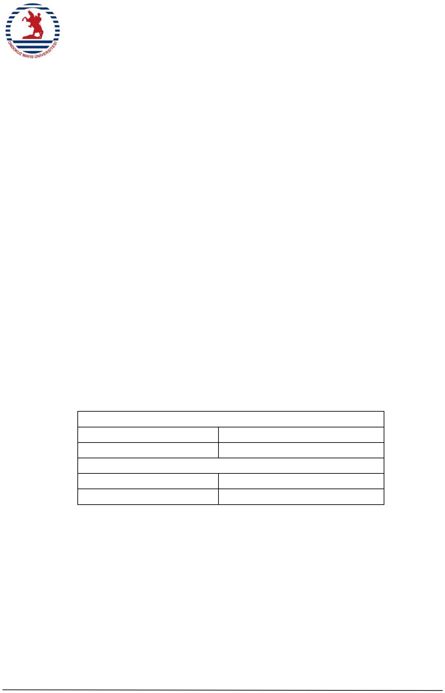
Date
01.07.2022
Number
2022-199

